



adges UI components library

**Component ID Inner Header - v1.0**

## Document Control

## Version History

|  |  |  |  |
| --- | --- | --- | --- |
| Version | Date | Author | Reason for Change |
| **1.0** | 14/10/2019 | Shaheen |  |
|  |  | Shaheen | Adding pattern to background |
| **1.1** | 23/09/2020 | Rijin Mukundan |  |
|  |  |  |  |
|  |  |  |  |
|  |  |  |  |
|  |  |  |  |
|  |  |  |  |

## Review History

|  |  |  |
| --- | --- | --- |
| Version | Reviewer | Date |
|  |  |  |
|  |  |  |
|  |  |  |
|  |  |  |
|  |  |  |
|  |  |  |
|  |  |  |

Table of Contents

Document Control 2

Version History 2

Review History 2

1. Document and components Purpose. 4
2. General Information. 4
3. How to use. 5
4. Component features and configure. 5
5. How to configure component. 6
6. Dependencies 6
7. Examples 8

# 

# Document and components Purpose.

The purpose of the document is to guide how use and configure Inner Header component.

The inner header is set to be as a banner in the page start, you can configure the component based on your branding guideline.

# General Information.

Component Name: Inner header.

Extension Theme: ex-inner-header.

Owner: Shaheen.

Version no: v1.0

Design

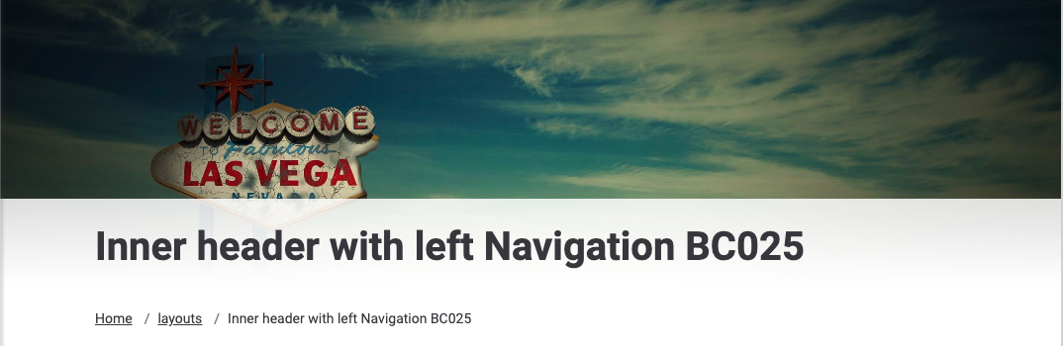

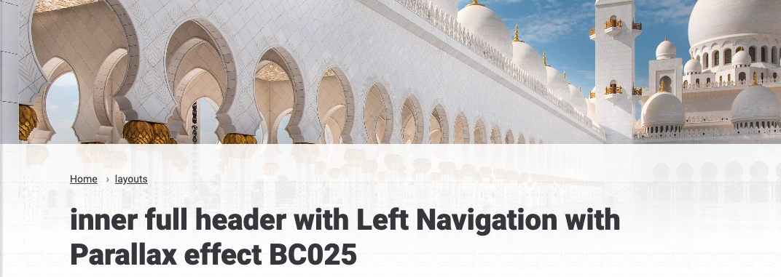

# How to use.

1. The available commands for this project .
   1. Compile : npm run gulp compile -- –path ex-inner-header –extension
   2. Compile & include under ADGE tenant : npm run gulp compile -- –path ex-inner-header –extension –full –dest [ADGEFolder]
   3. Deploy : npm run gulp deploy -- –path ex-inner-header –extension
2. *Now project have full copy from this extension theme under the project theme and you can apply the project brand guideline and configure component based on project needs.*

# Component features and configure.

You have access now to configure component with the below item.

$inner-header-min-height: 310px !default;

$inner-header-text-color: $white-color !default;

$inner-header-info-section-default-text-color:$white-color !default;

$inner-header-info-section-text-color: $black-color !default;

$inner-header-info-section-default-padding : 25px 0 !default;

$inner-header-border-size : 5px !default;

$inner-header-border-color : $primary-color !default;

$inner-header-infosection-bg-start : color-opacity($white-color, 0.8) !default;

$inner-header-infosection-bg-end : color-opacity($white-color, 1) !default;

$inner-header-infosection-precentage-start : -23% !default;

$inner-header-infosection-precentage-end : 88% !default;

$inner-header-big-slogan-font-size : 36px !default;

$inner-header-big-slogan-line-height : 46px !default;

$inner-header-aligment-responsive-padding:15px !default;

$inner-header-aligment-responsive-margin:0 !default;

$ex-iner-header-pattern-opacity:30% !default;

$inner-header-breadcrumb-color: $black-color !default;

$inner-header-breadcrumb-separator-color: $black-color !default;

$inner-header-breadcrumb-background: transparent !default;

$inner-header-breadcrumb-seperator-color : $grey-700 !default;

$inner-header-breadcrumb-font-size : 14px !default;

$inner-header-breadcrumb-item-padding : 0.75rem 0 !default;

$inner-header-breadcrumb-item-padding-responsive : 0.75rem !default;

$inner-header-breadcrumb-seperator-padding-left : 0.5rem !default;

$inner-header-breadcrumb-responsive-margin:-15px !default;

$inner-header-breadcrumb-text-color: $black-color!default;

$inner-header-breadcrumb-dropdown-background:$white-color !default;

$inner-header-breadcrumb-dropdown-item-color: $black-color !default;

$inner-header-breadcrumb-dropdown-item-size: 14px !default;

$inner-header-breadcrumb-dropdown-sm-back-text-decoration: underline !default;

$inner-header-background-y-position : -2px !default;

$inner-header-background-x-position : center !default;

$inner-header-background-size : cover !default;

$inner-header-afterline-color : $body-bg !default;

# How to configure component.

# How to configure the component.

There are various ways to configure the component:

1. **CSS Class / Data Configuration (on the variant)**

**CSS Class Configuration Method**

These styles can be applied in the variant to get the desired result

|  |  |  |
| --- | --- | --- |
| Feature | Modifier | Default value |
| Pattern for the inner header | ex-inner-header--pattern |  |
| Image with parallax for the inner header | ex-inner-header--parallax |  |

1. **Adding Built-In or Bootstrap Class (on the variant)**
   1. Spaces, Font weights, Display, Position properties etc can be added by bootstrap classes
      1. i. Spacing: <https://getbootstrap.com/docs/4.0/utilities/spacing/>
      2. ii. Flex: <https://getbootstrap.com/docs/4.4/utilities/flex/>
      3. iii. Font: <https://getbootstrap.com/docs/4.0/content/typography/>
   2. These classes should only be added to match the design
   3. For built-in classes check 7 Below to see the entire list
2. **SCSS Variable Override (on the _override.scss file)**

To configure the component we can take the above variables from section **4. Component features and configure** and add them to: adge-ph2/themes/<ADGE>/vars/_override.scss, this file with your desired changes to match the design.

1. **Complete style override**
   1. This should be the last and final option if the above 3 didn’t get you the desired output
   2. This is overwriting the SCSS of the component by adding your own style to it
   3. **Note: Take permission before doing this override**
   4. Instructions:
      1. Open the file /adge-ph2/themes/<ADGE>/sass/overrides.scss and add your own SCSS styles to override the faulty component.

# Dependencies

components-img-card.css

component-truncate.js

omponents-img-card.js

# Examples

Examples1:

I need to change text color.

I’ll copy the below variables from extension theme.

$info-section-text-color: $primary-color;

Then will paste the above variable in project folder theme in file _custom.scss and change with any variable based on site needs.

$breadcrumb-text-color: $secondary-color;